Pantry List & Shopping List

From our team discussion and all our individual designs, we have decided to combine our idea of having a Pantry List and a Shopping list into a single major feature of our application. This will help our application be more organized and simplistic. This will be managed by a simple button bar once in this section of the application.

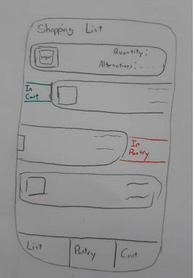The first section will be the shopping list. This section will include:

* Quick add of ingredients from searching recipes, with amounts included;
* Quick share with others;
* Alternative suggestions;
* Search functions, with filters (ex. Freezer) for quick find when at the store and;
* 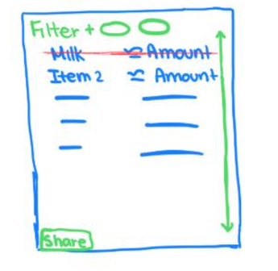This may also include a quick shop, where users may be able to quick buy and pick up from popular stores.

When users want to make a recipe that they need to buy ingredients for, they can quickly add these items to the shopping list for the next time they go to the store. They are also able to share with others, and this crosses out or adds ingredients in real time once any changes are made.

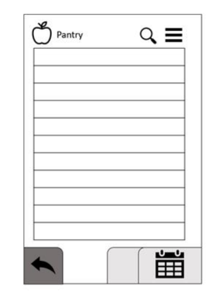

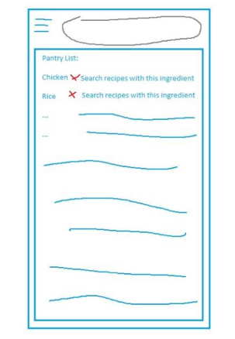For the pantry list section, all our proposals were generally the same. Users will be able to:

* Add new items, amount and expiry dates to the list of items;
* Have a search function to find items;
* Click items and find recipes using their at home ingredients and;
* Quick add items back to their shopping list.

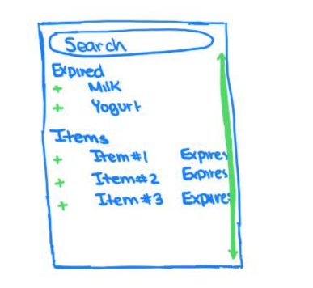Including these features, the user will be able to quickly check what items they have a home such that at home items with not expire without the users knowledge and they are able to filter recipe searches with ingredients users do have at home.